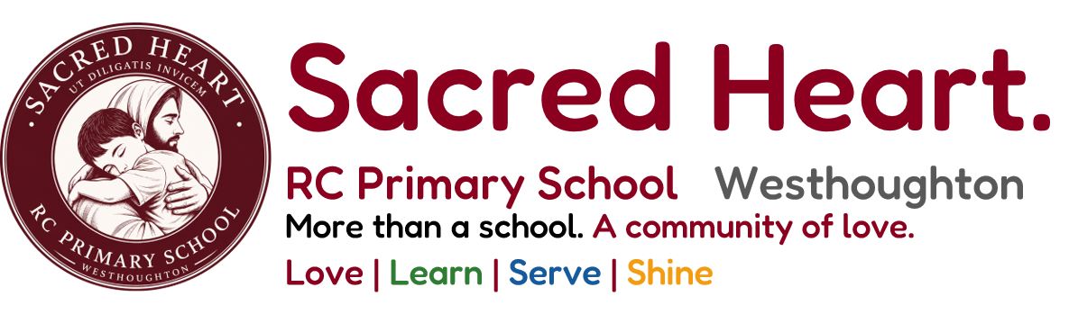
Freedom of Information: Publication Scheme, Guide to Information and Schedule of Fees

Prepared: October 2026 | Proposed Governing Board approval: 2 December 2026 | Review: December 2027

1. Adoption of the ICO model publication scheme
Sacred Heart RC Primary School is a voluntary aided maintained primary school and a public authority for the purposes of the Freedom of Information Act 2000. The school will adopt the Information Commissioner’s Office (ICO) model publication scheme unchanged, subject to formal Governing Board approval. The scheme, this school-specific Guide to Information and the Schedule of Fees will be accessible to the public. The school will maintain and review the information it makes available.
Official ICO model publication scheme (unchanged): https://ico.org.uk/media/for-organisations/documents/1153/model-publication-scheme.pdf
ICO guidance: https://ico.org.uk/for-organisations/foi/publication-schemes-a-guide/

2. Guide to information
The following guide identifies the classes of information that the school routinely makes available. Information can be accessed through the school website, or requested from the school office where indicated. Personal information, confidential safeguarding material and legally exempt information are not routinely published.

1. Who we are and what we do
School contact details; school status and Catholic character; leadership and staff roles; Governing Board membership, structure and responsibilities; school term dates and session times.
How to access: Website: Contact Us, Meet the Team, Governance, Term Dates and Session Times; office on request.

2. What we spend and how we spend it
Published financial information and relevant funding statements; pupil premium strategy; PE and sport premium reporting; charging and remissions; financial governance information and expenditure records falling within the ICO schools guide.
How to access: Website: Statutory Information and School Policies; further routinely disclosable financial records via office on request.

3. What our priorities are and how we are doing
School vision, improvement priorities, published development summaries, performance information, Ofsted and Catholic Schools Inspectorate reports, relevant annual reports and school evaluation information available for publication.
How to access: Website: Welcome, School Improvement, Performance and Inspection pages; office on request.

4. How we make decisions
Governing Board structure and remit; published governance information; non-confidential minutes and records of decisions where disclosable; admissions arrangements and appeals information.
How to access: Website: Governance and Admissions. Approved, non-confidential minutes of Governing Board and committee meetings, agendas and relevant papers may be inspected at the school office by prior appointment. Electronic or paper copies may also be requested. Personal, confidential or otherwise lawfully exempt material may be redacted or withheld. Inspection arrangements do not limit the right to request information under FOIA.

5. Our policies and procedures
Published statutory and school policies including safeguarding, behaviour, complaints, SEND, accessibility, admissions, equality, attendance, curriculum and charging, as applicable.
How to access: Website: School Policies and relevant subject pages; paper copies from office.

6. Lists and registers
Registers and lists that the school is required or permitted to make public, including relevant governance registers and asset or interest information where disclosable.
How to access: Website: Governance where published; otherwise contact the school office. The register of governors’ interests is available on request, subject to any lawful restrictions. Pupil admission and attendance registers are not generally available for public inspection and are not listed as routinely published information.

7. The services we offer
Education and curriculum provision; SEND support; school meals, wraparound care, enrichment, music, parish links, admissions and family support services.
How to access: Website: Curriculum, SEND/Inclusion, Meals, Wraparound Care, Admissions and Contact Us.

3. How to request information
Freedom of Information requests may be sent to Global Policing, which the school’s published Contact Us page identifies as handling FOI requests on the school’s behalf: datarequests@globalpolicing.co.uk; telephone 0161 510 2999. Please identify Sacred Heart RC Primary School, Westhoughton. Alternatively, write to the School Business Manager, Sacred Heart RC Primary School, Central Drive, Westhoughton, Bolton BL5 3DU; office@sacred-heart.bolton.sch.uk; 01942 634681. The School Business Manager coordinates the school’s internal records and liaison with Global Policing. The school remains responsible for meeting its legal obligations.
A Freedom of Information request should describe the information sought and provide a name and correspondence address (including an email address). The school normally responds to valid requests within 20 school days or 60 working days, whichever is shorter, excluding applicable statutory exceptions. Requests for a person’s own personal data are handled separately under data protection law. Environmental information requests are handled under the Environmental Information Regulations 2004.
Where information is already available, the school may explain how to access it. Where information is not held or an exemption applies, the school will respond as required by law. Applicants may request an internal review and may complain to the Information Commissioner’s Office. Requests for personal information about the requester (subject access requests) are handled under data protection law; see https://www.sacred-heart.bolton.sch.uk/data-protection/.

4. Schedule of fees
The school aims to make routine information available without charge. Fees will be notified in advance and will not be levied unless lawful and disclosed in this schedule. The schedule applies to information supplied under the publication scheme; statutory charging rules for individual FOI requests are separate.
Information / method | Charge
Viewing information on the school website | Free
Information supplied by email or electronic download | Free
Paper copies of information already published on the school website requested by parents | Free
Other paper copies under this scheme | Free as the school’s current default; any exceptional charge requires a published revised schedule before being applied
Postage for routine requests | Free as the school’s current default
Information for which another statute expressly permits a fee | Only the applicable statutory fee, explained in advance
Commercial publications, if any | Price clearly stated before purchase; none currently listed in this guide
This schedule does not remove the school’s ability to apply the statutory FOI appropriate-limit or fee provisions to individual requests where the law permits. No charge will be made simply for viewing information online.

5. Accessibility and alternative formats
The school will make reasonable adjustments to support access to published information. Paper copies of information on the school website are available free of charge. Anyone needing an accessible format, translation support or assistance locating information should contact the school office.

6. Maintenance, review and accountability
The Executive Headteacher has overall responsibility for maintaining the publication scheme, guide and fee schedule. The School Business Manager coordinates information held by the school and liaises with Global Policing, which handles FOI and subject access requests on the school’s behalf according to the published Contact Us page. The Governing Board oversees statutory compliance. The guide and schedule will be reviewed at least annually and updated when information or access routes change. The Data Protection page is https://www.sacred-heart.bolton.sch.uk/data-protection/.

7. Publication instructions
Publish this Guide to Information and Schedule of Fees on a Freedom of Information webpage under Statutory Information, alongside a direct link to the unchanged ICO model publication scheme. Cross-link the page from School Policies, Contact Us and Data Protection. The guide may be published before formal adoption only if its approval status is made clear; following approval, record the actual Governing Board decision and date.
Official reference: Information Commissioner’s Office, Publication schemes: a guide; ICO model publication scheme and template guide for smaller schools.

