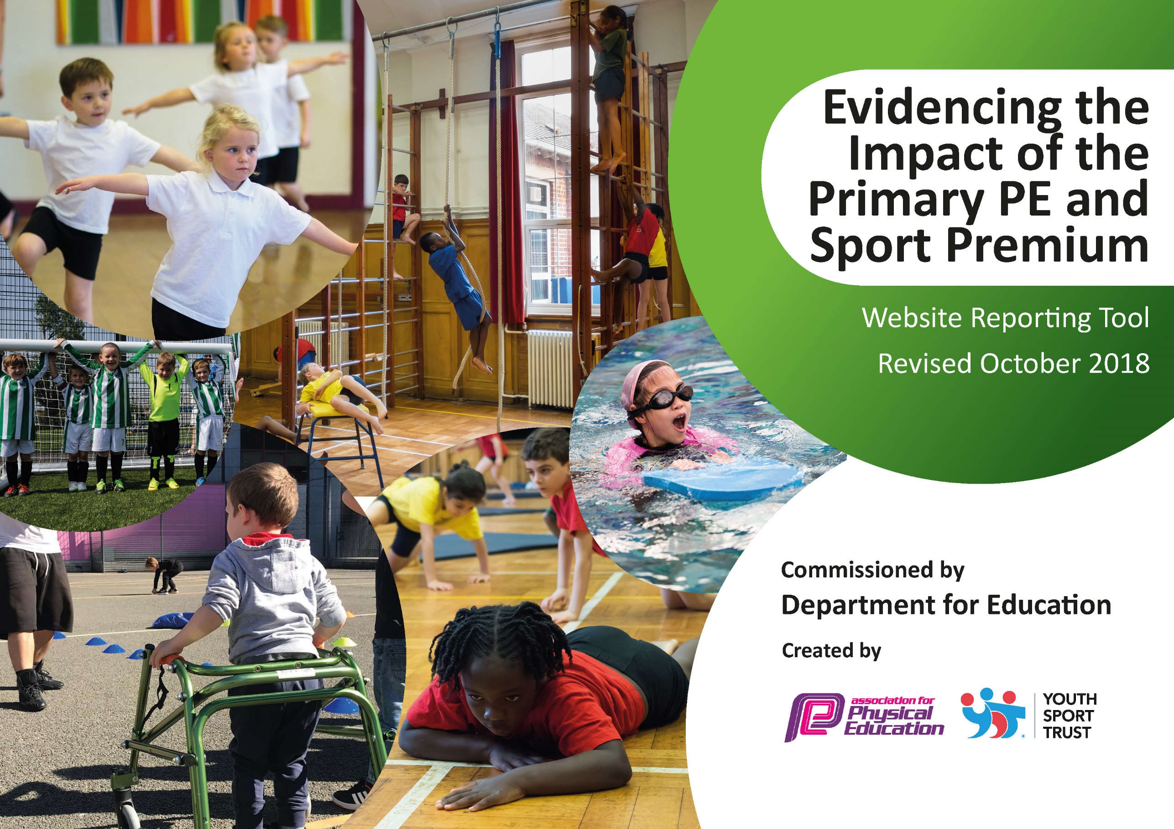
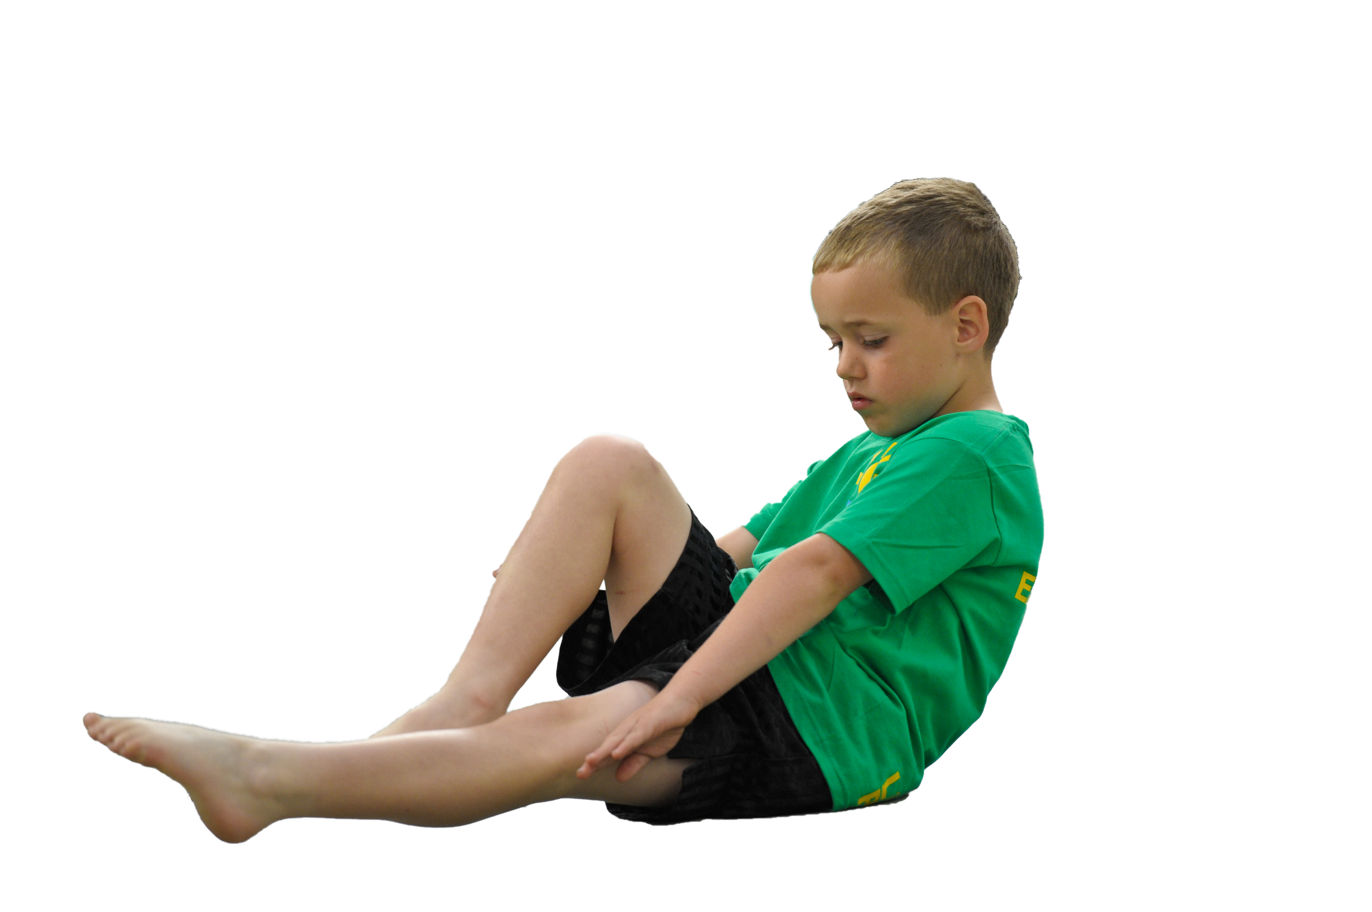
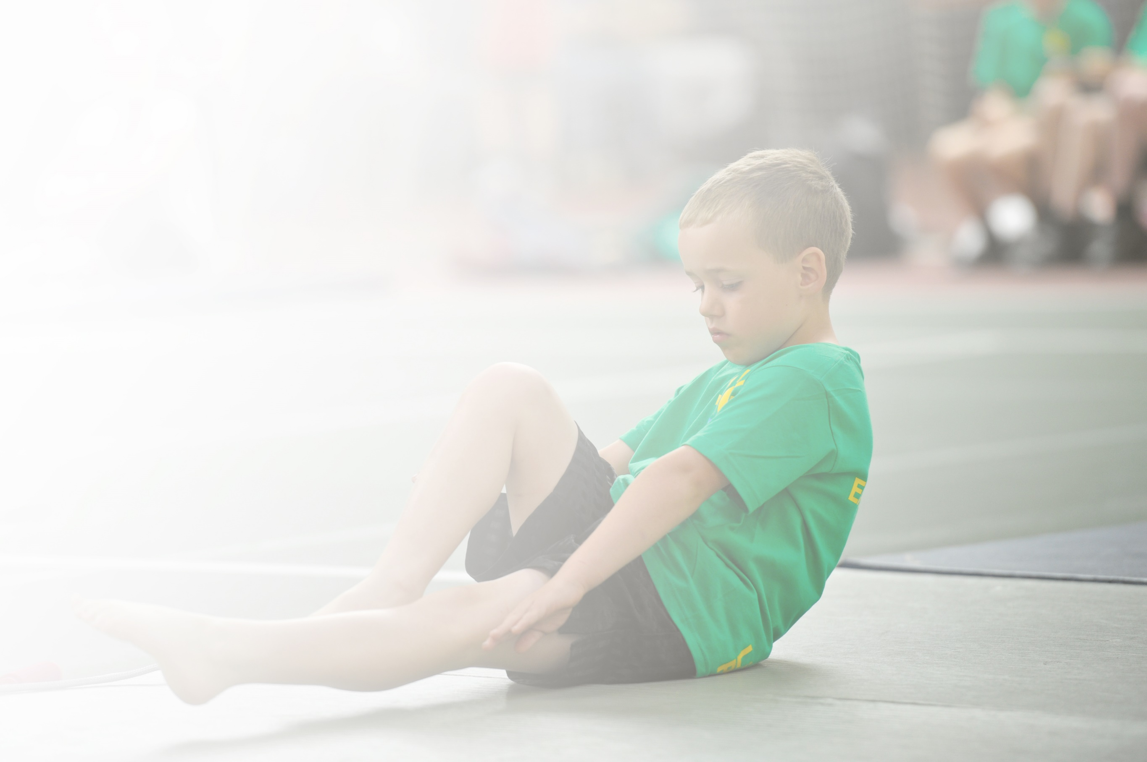
Schools must use the funding to make additional and sustainable improvements to the quality of Physical Education, Sport and Physical Activity (PESPA) they offer. This means that you should use the Primary PE and Sport Premium to:

- Develop or add to the PESPA activities that your school already offer
- Build capacity and capability within the school to ensure that improvements made now will benefit pupils joining the school in future years

Please visit gov.uk for the revised DfE guidance including the 5 key indicators across which schools should demonstrate an improvement. This document will help you to review your provision and to report
your spend. DfE encourages schools to use this template as an effective way of meeting the reporting requirements of the Primary PE and Sport Premium.

We recommend you start by reflecting on the impact of current provision and reviewing the previous
spend. Under the Ofsted Schools Inspection Framework, inspectors will assess how effectively leaders use the Primary PE and Sport Premium and measure its impact on outcomes for pupils, and how effectively governors hold them to account for this.

Schools are required to publish details of how they spend this funding as well as on the impact it has on pupils’ PE and sport participation and attainment by the end of the summer term or by 31 July 2019 at the
latest.
We recommend regularly updating the table and publishing it
on your website throughout the year, as evidence of your
ongoing review into how you are using the money to
secure maximum, sustainable impact. To see an
example of how to complete the table please
click HERE.

Support for review and reflection - considering the 5 key indicators from DfE, what development needs are a priority for your setting and your students now and why? Use the space below to reflect on previous spend, identify current need and priorities for the future.

Key achievements to date: | Areas for further improvement and baseline evidence of need:
- Higher range of less active children now participating in extra-curricular activity  - Continued high attendance of afterschool clubs across both KS1 and KS2  - Ranked 6th In Bolton for commitment to competition and competitive sports  - Lesson plans, Medium Term Plans and LO’s for all year groups to help teachers deliver high quality PE.  - Range of competitions, friendlies and events entered have allowed an increased number of children attending to enrich their opportunity in competitive sport.  - Winning the Bolton School Games for Tag Rugby and being invited to attend the Greater Manchester Games | - Increased focus on swimming and personal survival  - Increased range of competitive and non-competitive sports being accessed (Basketball, Cricket and Hockey, Cheer leading)  - CPD opportunities for all staff to raise confidence and higher quality of PE teaching and assessment.

Meeting national curriculum requirements for swimming and water safety | Please complete all of the below:
What percentage of your current Year 6 cohort swim competently, confidently and proficiently over a distance of at least 25 metres?  N.B. Even though your children may swim in another year please report on their attainment on leaving  primary school. | 98.38 %
What percentage of your current Year 6 cohort use a range of strokes effectively [for example, front crawl, backstroke and breaststroke]? | 98.38 %
What percentage of your current Year 6 cohort perform safe self-rescue in different water-based situations? | 67.75%
Schools can choose to use the Primary PE and Sport Premium to provide additional provision for swimming but this must be for activity over and above the national curriculum requirements. Have you used it in this way? | NO

Action Plan and Budget Tracking
Capture your intended annual spend against the 5 key indicators. Clarify the success criteria and evidence of impact that you intend to measure to evaluate for students today and for the future.

Academic Year: 2019/20 | Total fund allocated: £15,600 | Date Updated: 19.7.19
Key indicator 1: The engagement of all pupils in regular physical activity – Chief Medical Officer guidelines recommend that primary school children undertake at least 30 minutes of physical activity a day in school |  |  |  | Percentage of total allocation:
 |  |  |  | %
School focus with clarity on intended impact on pupils: | Actions to achieve: | Funding allocated: | Evidence and impact: | Sustainability and suggested next steps:
- Pupils engage in 2 hours of P.E. every week (evidenced on whole school time table)  - KS2 Sports Day Bolton Arena  - Employment of lunchtime sports coach  - PE resources/equipment | - Employing a specialist teacher of Physical Education to deliver high quality P.E. lessons for each year group once a week (Key PE Sports)  - June 2018 Sports Day TBC and sports specific activities. Coach travel to be provided to take staff and children to and from Bolton Arena.  - Sports coach to work with lunchtime leaders in delivering high quality structured games in parallel with the 30:30 initiative.  - To make sure all staff are well equipped with resources to deliver PE lessons indoor and outdoor and to make sure there is adequate equipment for lunchtime leaders to support lunchtime games. | £12,500  £750  £3500  £1000 | - Enhanced, inclusive, more exciting curriculum provision. Wider range of activities for children to perform that are fun and enjoyable, yet engaging. Skill based curriculum allows children to transfer a wide range of skills across different sports and can understand and explain what they are doing in PE and why they are doing it.  - KS2 Sports Day held at Bolton Arena using Sports Inclusion coaches. Teachers each have an event to oversee. Children experience a wider range of activities at a competitive venue such as javelin, shot put and 400M. Opportunities for children to see, take part and experience sports that are not timetabled on the curriculum for long periods and lunch time and after school clubs.  - Children will be active throughout lunch and experience a range of games and sports aimed at encouraging children to be healthy and active. Lunchtimes should run smoothly and encourage children to play fair, build communication, resilience and confidence.  - A wide variety of equipment enables staff to deliver the full PE Curriculum to its maximum potential. Adequate equipment ensures all children can participate and access the curriculum focuses. Lunchtime equipment provides staff and children with the resources to enjoy, create and participate in a wide variety of games and activities to tackle exercise, active lifestyles and obesity.
Key indicator 2: The profile of PESSPA being raised across the school as a tool for whole school improvement |  |  |  | Percentage of total allocation:
 |  |  |  | %
School focus with clarity on intended impact on pupils: | Actions to achieve: | Funding allocated: | Evidence and impact: | Sustainability and suggested next steps:
- Sports leaders and prefects to be trained in delivery of high quality sporting activities.  - Delivering new sessions such as Table Tennis, Tri golf, Y-Ball, Scooter Boarding and Futsal  - CPD and support teachers in high quality PE delivery.  - Develop analysis of performance skills Links with other subjects such as Science, Music and Computing | - Develop communication, teamwork, social and organisational skills through leading in sporting activity. Year 6 leaders and prefects to officiate class competitions when necessary. (DS, MW and Safron to train leaders)  - Based upon pupil voice, network with people who can come in and deliver taster sessions for new sports such as basketball, tennis and Multi-sports  - Release time for subject specialists to work alongside staff in delivering high quality and effective PE as well as subject monitoring.  - Using school IPad to video performances of children and encourage children to discuss demonstrations. | Included In (£12,500)  Built into (£3500 cost of Safron)  £1000 | - Pupil’s confidence and desire to lead and officiate is increased. More Year 5/6 pupils wanting to become leaders and prefects and take part in supporting raising profile of PE. Sports prefects to run interclass/house competitions and officiate games at lunchtimes.  - Increased participation in extra-curricular clubs and children to gain more confidence. Increased participation in PE. Wider take up of clubs outside of school with signposting. Inactive children may find a game/sport that they enjoy as well as identify any gifted and talented children.  - To raise the quality of teaching in PE and Sport. Time for primary staff to develop knowledge, confidence and skills to teach PE. To increase pupil participation in PE and use new lesson plans with assessment.  - Providing videos gives children the opportunity to see their movement, skills and exercise and see areas to improve. It allows children who are more capable to show techniques, improve their existing technique and allows children to edit videos through using media. Supports assessment as teachers can see routine on film such as gymnastics routines which supports best fit when it comes to assessment for PE and allows staff the opportunity to spot children who might be G+T/need further development. Develop use of ICT to promote engagement in PE (targets less sporty pupils and increase enjoyment and engagement) Children to use QR codes and update PE notice board. Sports Council to support this.

Key indicator 3: Increased confidence, knowledge and skills of all staff in teaching PE and sport |  |  |  | Percentage of total allocation:
 |  |  |  | %
School focus with clarity on intended  impact on pupils: | Actions to achieve: | Funding  allocated: | Evidence and impact: | Sustainability and suggested  next steps:
- Increase confidence of staff delivering and teaching PE. | - Dale Spencer/PE Coordinator and other specialists delivering staff meetings/courses to staff in areas of PE highlighted as needing development.  - Staff audit - questionnaires to define areas that teachers want to improve/support. Use Learning Walks/Drop Ins/PE observation to highlight areas people need support with. MW/GH/DS Audit will direct support offered by DS | Cost included within from Key Indicator 1 at £12, 500 | - Courses held at Sacred Heart and other schools for staff to attend. PE cluster meetings have all discussed potential coaches/ experts who can deliver staff training on a range of sports in the PE Curriculum  - Staff questionnaires identify where staff feel they need/would like more support to better their practice. Drops enable MW/GH/DS to better assist staff with these developments and identify areas for further improvement
Key indicator 4: Broader experience of a range of sports and activities offered to all pupils |  |  |  | Percentage of total allocation:
 |  |  |  | %
School focus with clarity on intended  impact on pupils: | Actions to achieve: | Funding  allocated: | Evidence and impact: | Sustainability and suggested  next steps:
- Continue to work with Westhoughton High in supporting swimming lessons for Y6. This year, Y5 will also be attending swimming. Anyone in Y5 who does not meet the criteria for 25M can be targeted for extra swimming provision. | - Bolton LA currently supporting with this with the use of their coaches and swimming pool. | (£3800) | - Year 5 and 6 take part in swimming lessons for one hour on a Monday at Westhoughton Swimming Baths. (Once a week/ 2 groups/ one-hour sessions in 10 week block) Children experience a sport that they might not take part in outside of school. Promotes active lifestyle and life skills. Provides children with fun and enjoyment
Key indicator 5: Increased participation in competitive sport |  |  |  | Percentage of total allocation:
 |  |  |  | %
School focus with clarity on intended  impact on pupils: | Actions to achieve: | Funding  allocated: | Evidence and impact: | Sustainability and suggested  next steps:
- Expose girls’ football to more friendly games and events. Development of girls and early year’s football through lunchtime and after school clubs.  - Paying annual fee to Bolton School Games for entry to competitions. | - Liaise with teachers/staff/BWFC community Trust and Poppy to continue from previous years.  - Use School games calendar, regular attendance at meetings and discussions with SGO’s | £1170  £150 annual fee | - Girls competing in friendlies, competitions and interclass competitions. More girls taking part in after school clubs, lunchtime games and clubs outside of school through signposting to local clubs and BWFC  - Broad range of sporting competitions entered that targets Gifted and Talented, Children who respect the values and inactive and low self-esteem children. Registers to be kept on attendance and impact to see children enjoying games and sports of their choice and finding a love of an active lifestyle. Encourage children to take up clubs outside of school through signposting.

